**Lab - Information Gathering Using Maltego CE**

**Overview**

The focus of Maltego is analyzing real-world relationships between information that is publicly accessible on the Internet. This includes footprinting Internet infrastructure as well as gathering information about the people and the organization who owns it.

**Hardware requirements for these labs:**

1. Do not use a Wi-Fi connection. Use an Ethernet cable to connect to the network. Wi-Fi is configured for IPSec which can impede the labs from working. The additional transport and tunneling protocols do not play well with Kali or Metasploit.

The first phase of security assessment is to focus on collecting as much information as possible about a target application.

According to OWASP, information gathering is a necessary step of a penetration test.

The more information, the higher the success rate. There are basically two types of information gathering: active and passive. Passive information gathering is where the attackers won’t be contacting the target directly and will be trying to gather information that is available on the Internet; whereas in active information gathering, the attacker will be directly contacting the target and will be trying to gather information.

Information gathering is generally done on infrastructure and on people. In infrastructure recon, the attackers generally try to find the information about the host, i.e., the mail exchanger record, name server record , shared resources, etc., For information gathering on people, the attackers try to gather information like email addresses, their public profiles, files publicly uploaded, etc., that can be used for performing a brute force, social engineering or Spear phishing.

**About OSINT:**

OSINT stands for Open Source Intelligence. In OSINT method, the information is basically found publicly, and that information can be used to further analysis. The relationship between the various forms of information gathered from the Internet can be extremely valuable from the attacker’s point of view. In this method, there is no direct contact with the victim’s servers or only standard traffic is directed toward the victim.

Maltego is an example which uses OSINT to gather information. **Maltego** is an open source intelligence and forensics application and shows how information is connected to each other. Another advantage of this tool is that the relationship between various types of information can give a better picture of how they are interlinked and can also help in identifying unknown relationships.

**What information can be found using Maltego CE:**

**Caveat**

**Maltego CE Restrictions and Limitations**

Maltego CE is the community version of Maltego that is available for free after quick online [registration](https://www.paterva.com/web7/community/community.php). Maltego CE includes most of the same functionality as the commercial version however it has some limitations. The main limitation with the community version is that the application cannot be used for commercial purposes and there is also a limitation on the maximum number of entities that can be returned from a single transform. In the community version of Maltego, there is no graph export functionality that is available in the commercial versions.

With Maltego, we can find the relationships, which (people) are linked to, including their social profile, mutual friends, companies that are related to the information gathered, and websites.

If we want to gather information related to any infrastructure, we can gather relationship between domains, DNS names, and netblocks.

**Starting Maltego**

First, go to Applications–>Kali Linux–>Information Gathering–>Maltego

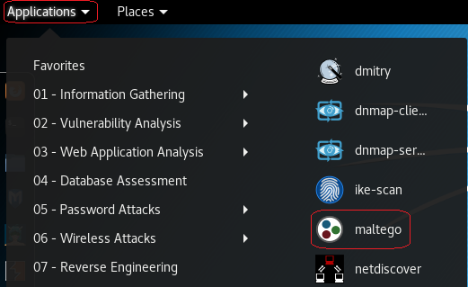

Maltego launches



Maltego minimizes to the quick launch bar. Click to open.

On the next screen, choose the Maltego CE (Free) edition and click Run.

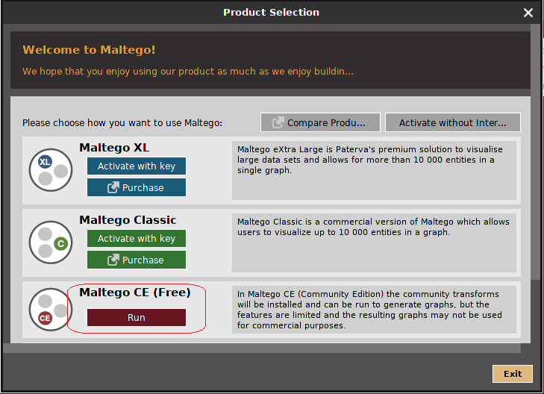

The first time you log in it will ask you to register your product.

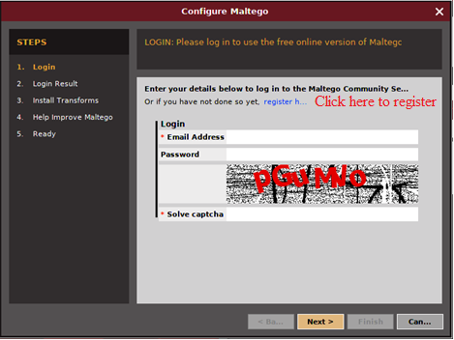

If you don't have the login information, you need to register yourself first by clicking on the **register here** link.  
   
The following screenshot shows the Register page scroll down to register an account:  
<https://www.paterva.com/web7/community/community.php>

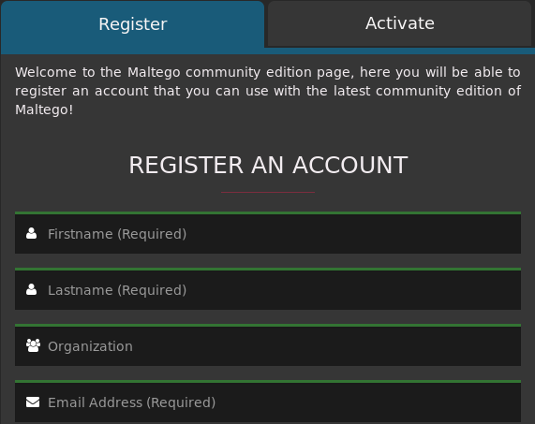

Your login will update the transforms.

You will see the Maltego welcome screen. After several seconds, you will see the  
following Maltego start-up wizard that will help you set up the Maltego client for the  
first time.

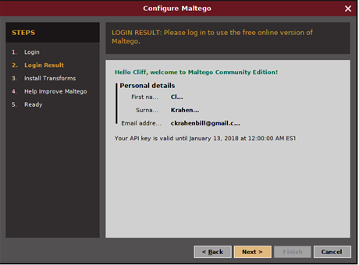

Click next to install the Transforms. Once the transforms have installed, click next.

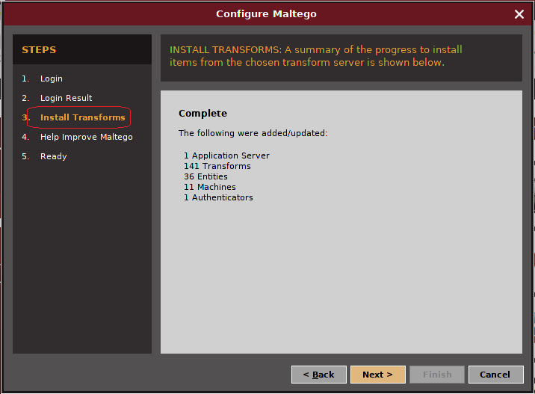

Choose to help improve Maltego.

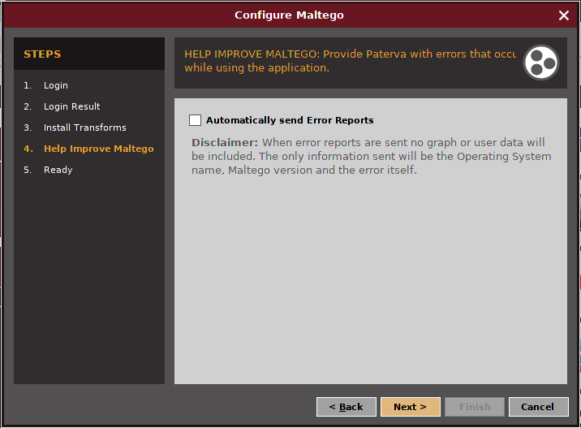

Accept the default radio button and click finish.

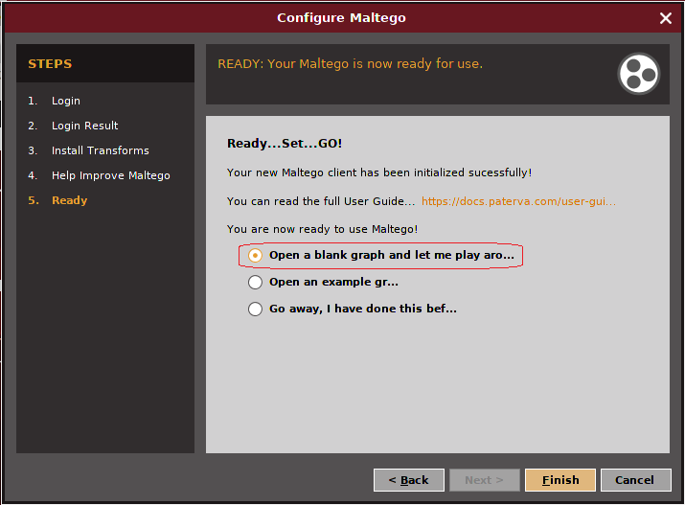

Once you click the finish button, Maltego will launch the new graph window. Place your mouse on the X in the top right corner to close the new graph window.

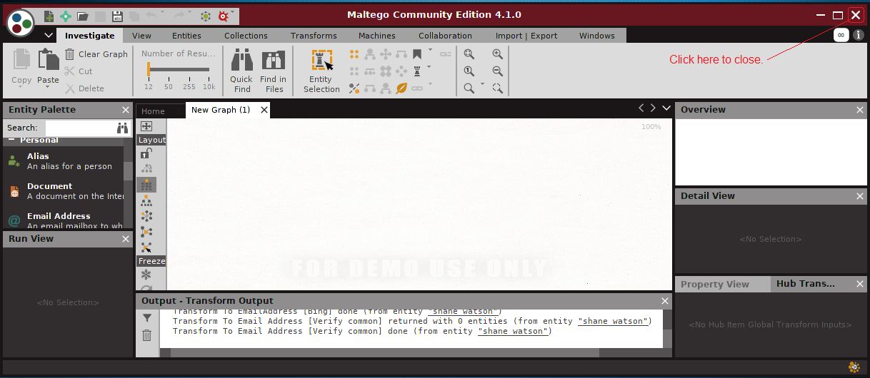

This brings us to the main management console. In the right window pane, you can look through the additional transforms that are available. Some these will require that you register for an API key and will require some additional configuration. As you become more proficient with Maltego, you might find these additional transforms to be needed.

From the management console window, go to the top left and click on the + sign to open a new graph window.

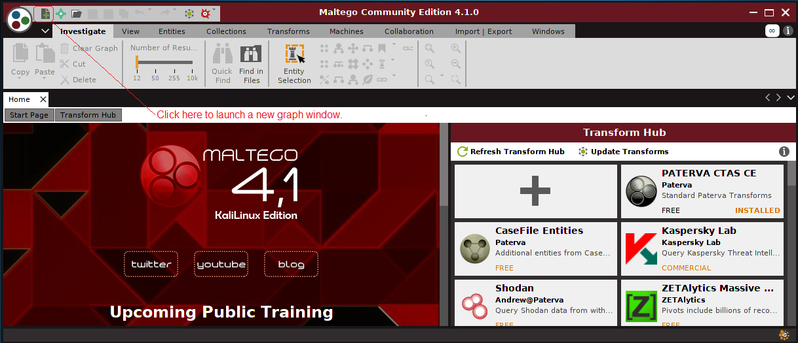

Over in the left windowpane, you will see all the different entities that we can gather information on. Using the slider bar in the left windowpane, scroll down until you come to, Domain.

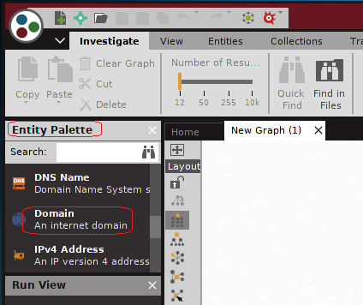

Using your left mouse button, drag the domain entity to the center of the graph and release.

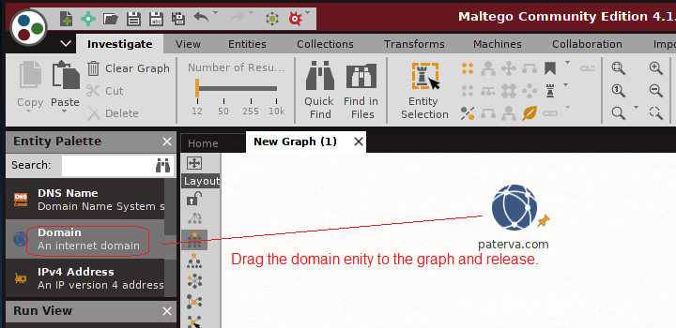

Click on the existing domain name until you get a cursor. Type in any domain of your choosing, or you can use the one shown in the video and in this lab, **syberoffense.com.**

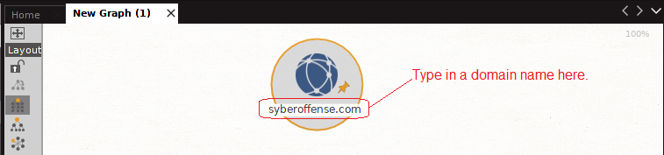

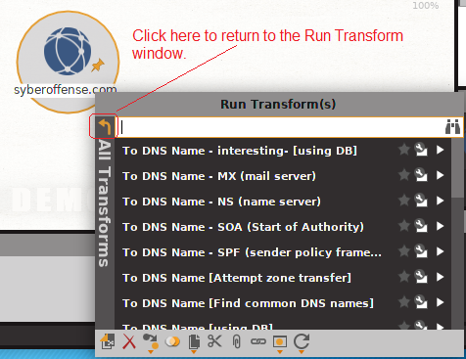Right-click on your domain name, and this brings up the run transform window. Click on the + sign next to All Transforms to see all the scripts or transforms that are about to run against your domain entity. Click on the back arrow to return to the All Transforms option.

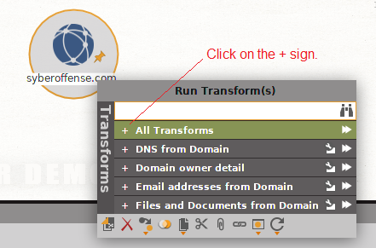

To the right of the green all transforms box, click on the start button to run the transforms.

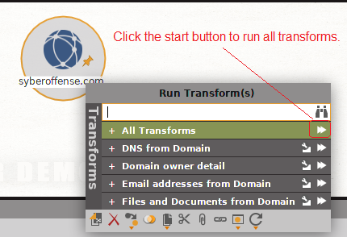

As the results of the transform search begin to return, the graph window begins to fill up. Using your left mouse button, you can click on the graph and use your scroll wheel; you can zoom in and out of the graph window.

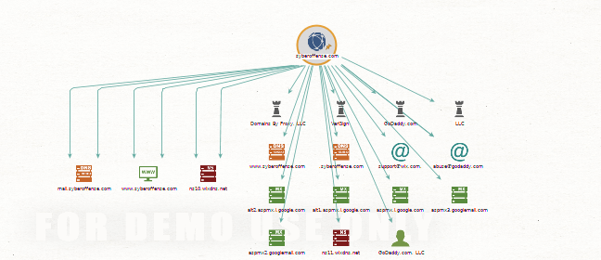

You can click on any of the results inside the graph to get more information about each of the transforms that we’re running. Depending on whether your whois information for the domain was made public or private, will depend on how much information about your domain search Maltego will gather.

**Gathering Information About an Individual**

At the top left of the console window, click on the + that opened a new graph.

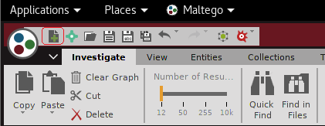

You will now have two graph windows tabbed side-by-side

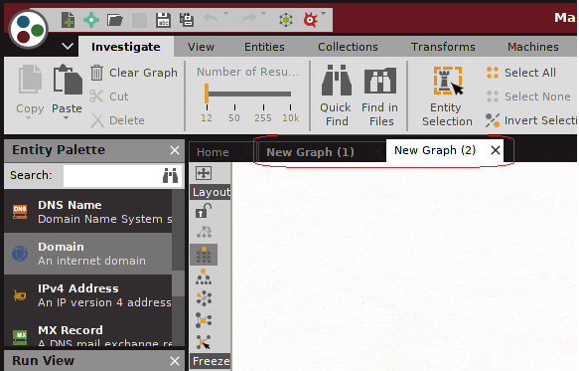

In the left windowpane marked entity palette, scroll down until you come to, Person. Using your left mouse button, select the entity Person and drag on to the graph window.

Click on the entity inside the graph window until you get a cursor where the name is. Change the name to any person you want or use the example I am showing in the video and in this lab. For this example, I am looking for information about an individual named Shane Watson



Right-click on the individual’s name and click on the start button to run all available transforms against this individual.

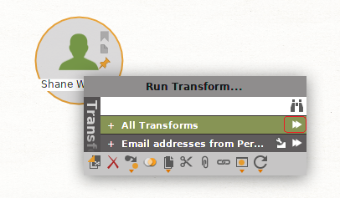

Choose whether to logon to your Twitter account or not.

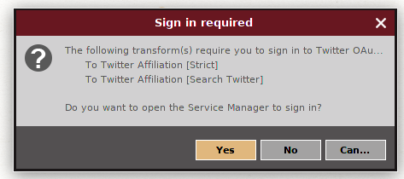

As with the domain transform results, you can click on any of the returned information to get more information about the transform in the right windowpane.

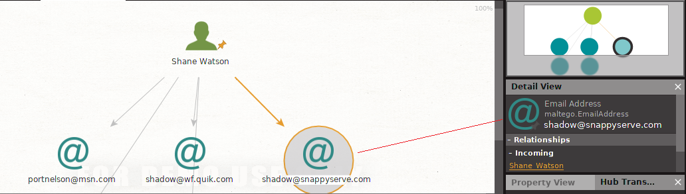

**Summary**

As we have seen in this lab, Maltego is a very powerful reconnaissance tool. Be sure to use your newfound powers for good and not evil. It is easy to see how such a tool could be used for stocking or cyberbullying.

End of the lab!